**Creating Microservices for account and loan**

Project Structure for AccountMicroservice:

Project Structure for LoanMicroservice:

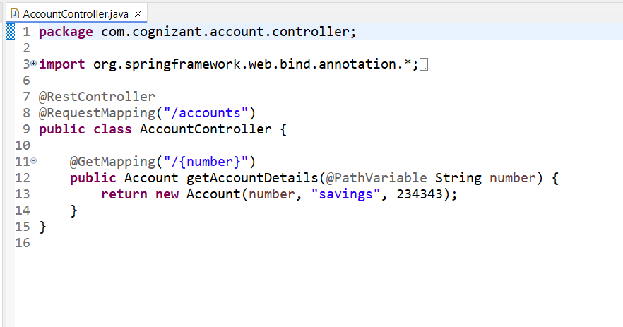

Account.java

**package** com.cognizant.account.model;

**public** **class** Account {

**private** String number;

**private** String type;

**private** **double** balance;

**public** Account(String number, String type, **double** balance) {

**this**.number = number;

**this**.type = type;

**this**.balance = balance;

}

**public** String getNumber() { **return** number; }

**public** String getType() { **return** type; }

**public** **double** getBalance() { **return** balance; }

}

Loan.java

**package** com.cognizant.loan.model;

**public** **class** Loan

{

**private** String number;

**private** String type;

**private** **double** loan;

**private** **double** emi;

**private** **int** tenure;

**public** String getNumber() {

**return** number;

}

**public** **void** setNumber(String number) {

**this**.number = number;

}

**public** String getType() {

**return** type;

}

**public** **void** setType(String type) {

**this**.type = type;

}

**public** **double** getLoan() {

**return** loan;

}

**public** **void** setLoan(**double** loan) {

**this**.loan = loan;

}

**public** **double** getEmi() {

**return** emi;

}

**public** **void** setEmi(**double** emi) {

**this**.emi = emi;

}

**public** **int** getTenure() {

**return** tenure;

}

**public** **void** setTenure(**int** tenure) {

**this**.tenure = tenure;

}

**public** Loan(String number, String type, **double** loan, **double** emi, **int** tenure) {

**this**.number = number;

**this**.type = type;

**this**.loan = loan;

**this**.emi = emi;

**this**.tenure = tenure;

}}

